**Stewart’s Theorem**

Stewart’s Theorem, though outside the Hong Kong Exam syllabus, is one of the important theorems in geometry. It is not too difficult to learn. See whether you can manage.

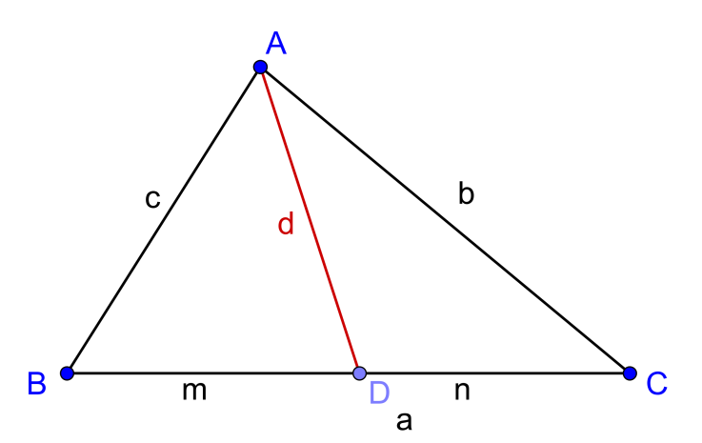

Given any triangle $ABC$. $AD$ is any arbitrary line. The base of the triangle: $a=m+n$.

**(a)** Prove Stewart’s Theorem: $b^{2}m+c^{2}n=a\left(d^{2}+mn\right)$ by:

**(i)** Pythagoras Theorem

**(ii)** using trigonometry.

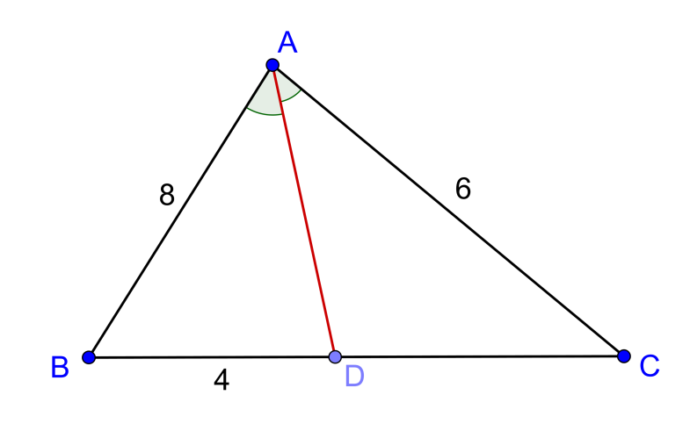**(b)**

In the diagram on the right,

$AD$ bisects $∠BAC$.

$AB=8, AC=6, BD=4,$

Find the length of $AD$.

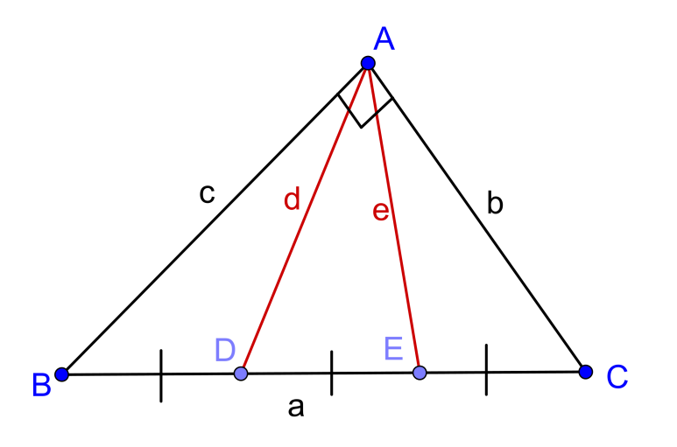**(c)** Prove that the sum of the square of the distances from the vertex of the right angle, in a right angled triangle, to the trisection point of the hypotenuse, is equal to $\frac{5}{9}$ the length of the hypotenuse:

$d^{2}+e^{2}=\frac{5}{9}a^{2}$

**(a)** **(i)** Draw a perpendicular line $AE$ from $A$ to $BC$.

Let $AE=h, ED=x,BE=m-x$

Then:

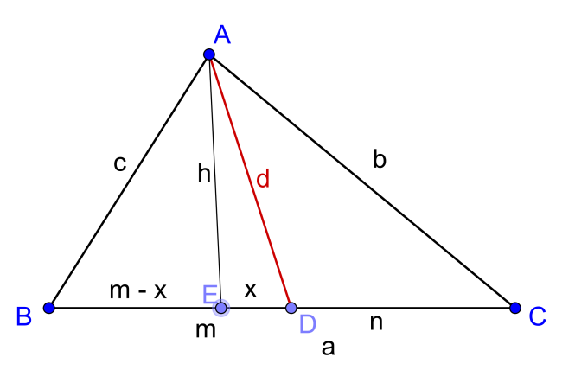 $b^{2}=h^{2}+{\left(n+x\right)}^{2} ….(1)$

$c^{2}=h^{2}+{\left(m-x\right)}^{2} ….(2)$

$d^{2}=h^{2}+x^{2} ….(3)$

$\left(1\right)-\left(3\right), b^{2}-d^{2}=n^{2}+2nx ….(4)$

$\left(2\right)-\left(3\right), c^{2}-d^{2}=m^{2}-2mx ….(5)$

$\left(4\right)×m,$ $b^{2}m-d^{2}m=n^{2}m+2mnx ….(6)$

$\left(5\right)×m,$ $c^{2}n-d^{2}n =m^{2}n-2mnx ….(7)$

$\left(6\right)+\left(7\right),$ $b^{2}m+c^{2}n-d^{2}\left(m+n\right)=mn\left(m+n\right)$

$b^{2}m+c^{2}n-{ad}^{2}=amn$

$b^{2}m+c^{2}n=a\left(d^{2}+mn\right)$

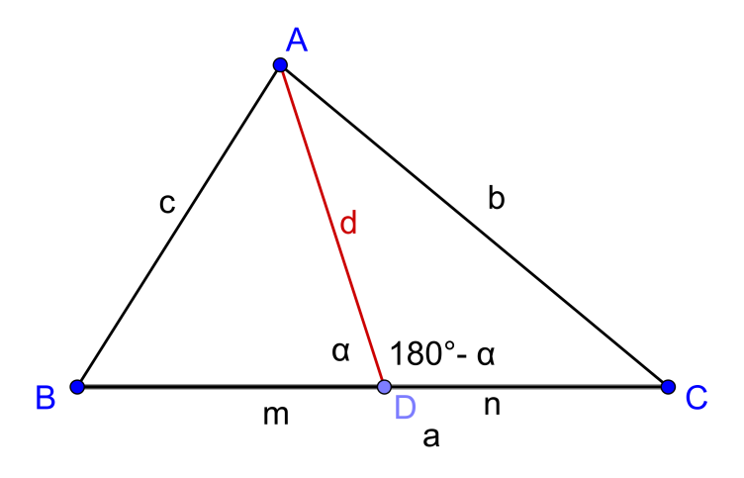 (ii) Let $∠ADB=α,∠ADC=180°-α$

By Cosine Law,

$\cos{α=\frac{m^{2}+d^{2}{-c}^{2}}{2md}} ….(1)$

$\cos\left(180°-α\right)=\frac{n^{2}+d^{2}{-b}^{2}}{2nd}$

$-cos α{=\frac{n^{2}+d^{2}{-b}^{2}}{2nd}} ….(2)$

$\frac{m^{2}+d^{2}{-c}^{2}}{2md}=-\frac{n^{2}+d^{2}{-b}^{2}}{2nd}$

$-m\left(n^{2}+d^{2}{-b}^{2}\right)=n\left(m^{2}+d^{2}{-c}^{2}\right)$

Rearrange and putting $a=m+n,$ we have

$b^{2}m+c^{2}n=a\left(d^{2}+mn\right)$

Stewart’s Theorem can be re-written in the form:

$man+dad=bmb+cnc$. (Mnemonic : A man and his dad put a bomb in the sink.)

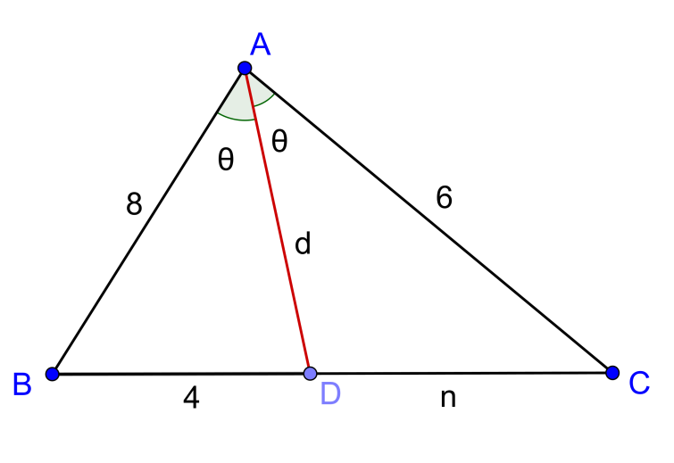**(b)** Let $∠BAD=∠CAD=θ$

Since

$\frac{Area of ∆ABD}{Area of ∆ACD}=\frac{4}{n}$

$\frac{\frac{1}{2}×8dsin θ}{\frac{1}{2}×6dsin θ}=\frac{4}{n}$

$∴n=3$

(This is angle bisector theorem: $\frac{8}{6}=\frac{4}{n}$. )

By Stewart’s Theorem

$b^{2}m+c^{2}n=a\left(d^{2}+mn\right)$

$6^{2}\left(4\right)+8^{2}\left(3\right)=7\left(d^{2}+4×3\right)$

$∴d=6$ (Taking positive root.)

**(c)** Apply Stewart theorem to $∆ABC$ in two ways, using $AD$ and $AE$ as the lines of cutting the triangle: $\left\{\begin{aligned}c^{2}\left(\frac{2}{3}a\right)+b^{2}\left(\frac{1}{3}a\right)=a\left[d^{2}+\left(\frac{2}{3}a\right)\left(\frac{1}{3}a\right)\right] \\ c^{2}\left(\frac{1}{3}a\right)+b^{2}\left(\frac{2}{3}a\right)=a\left[e^{2}+\left(\frac{2}{3}a\right)\left(\frac{1}{3}a\right)\right]\end{aligned}\right.$

$\left\{\begin{aligned}c^{2}\left(\frac{2}{3}\right)+b^{2}\left(\frac{1}{3}\right)=d^{2}+\left(\frac{2}{3}a\right)\left(\frac{1}{3}a\right) \\ c^{2}\left(\frac{1}{3}\right)+b^{2}\left(\frac{2}{3}\right)=e^{2}+\left(\frac{2}{3}a\right)\left(\frac{1}{3}a\right)\end{aligned}\right.$

Adding, we have $c^{2}+b^{2}=d^{2}+e^{2}+{\frac{4}{9}a}^{2}$

By Pythagoras Theorem, $a^{2}=d^{2}+e^{2}+{\frac{4}{9}a}^{2}$

${∴ d}^{2}+e^{2}=\frac{5}{9}a^{2}$

**Yue Kwok Choy**

**19/8/2016**